A Family Tree Web Application(For My family)

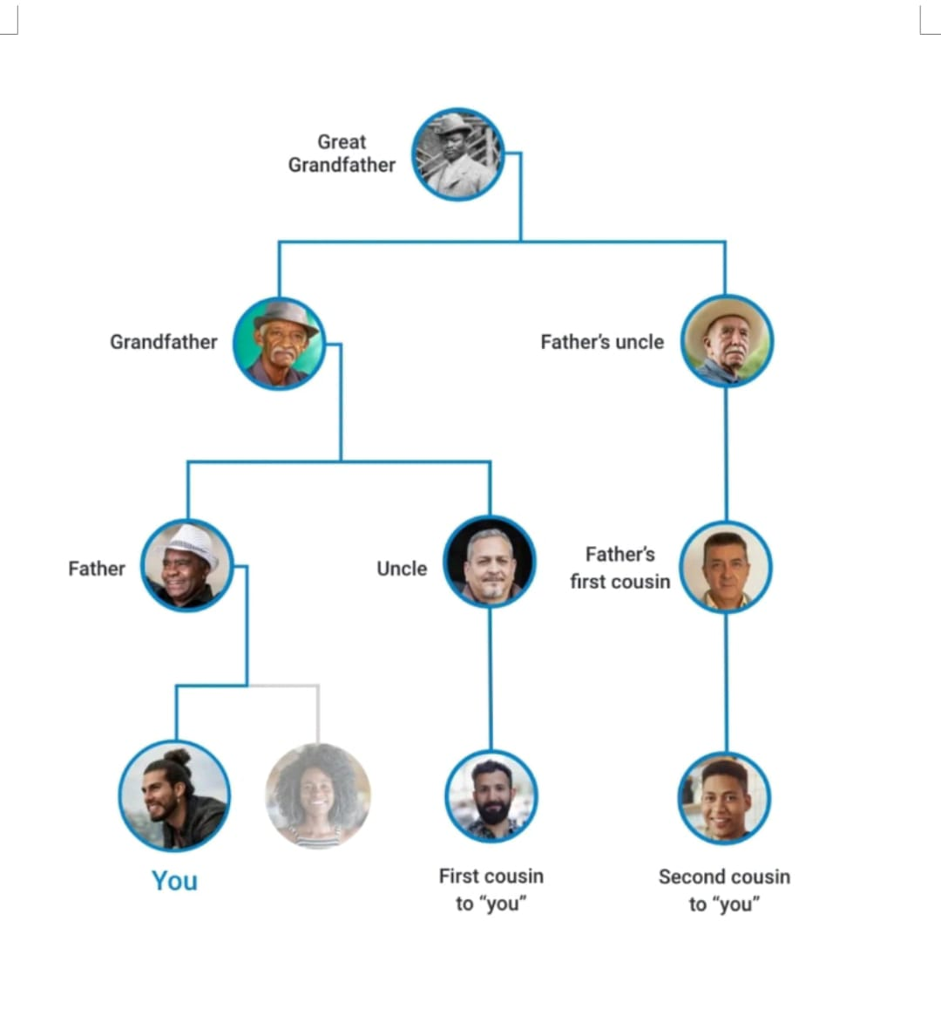
Simple family tree application for 7 generations ....track all family members
Capture all.details of family members .7 generations .and show in this tree manner (with relation)with a login page for user ....with email or phone otp generate password .
2 formats ..tree ,inverted tree
Pls make a practical tree
With maternal and paternal linkages
Ex...
Paternal :
.great grand son....grand son..son..father ..grand father ,great grand father ,great great grand father ( for all spouse must)
Maternal...
great grand son....grand son..son..mother ..grand father ,great grand father ,great great grand father (for all spouse must)
Both wife and husband must be depicted if married in each level
Unique id tag for family
ABCXY-ABCXY-ABCXY-ABCXY-ABCXY-ABCXY-ABCXY
for each generation one identifier ABC
X..male or female
Y...M.married or U..unmarried or D.divorce
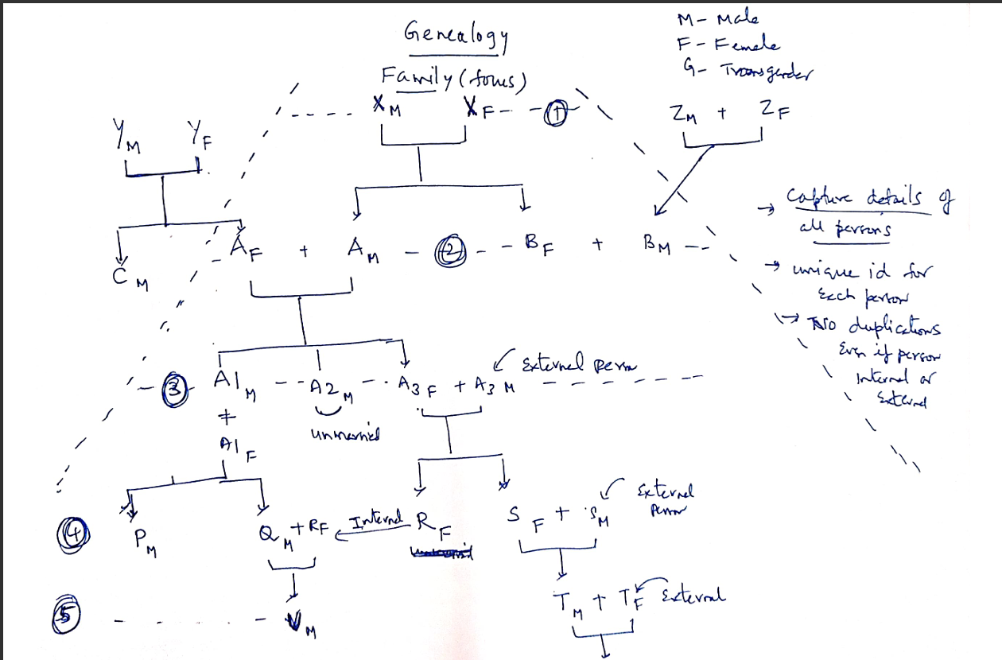
There are internal and external persons taken as spouse ...marital links
Practically

Each person must be identified uniquely

All relations are as per Hindu undivided family

No polygamy ..multiple spouses allowed only after death of first spouse

